PIZZA SALES SQL QUERIES

- KPI:
- Total Revenue:
SELECT SUM(total_price) AS Total_Revenue FROM pizza_sales;

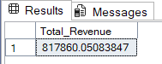
- Average Order Value
SELECT (SUM(total_price)/count(DISTINCT order_id)) AS Average_Order_Value FROM pizza_sales;

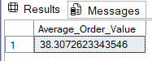

- Total Pizzas Sold
SELECT SUM(quantity) AS Total_Pizzas_Sold FROM pizza_sales;

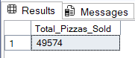

- Total Orders
SELECT count(DISTINCT order_id) AS Total_Orders FROM pizza_sales;

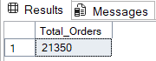

- Average Pizzas per order
SELECT (CAST(CAST(SUM(quantity) AS DECIMAL(10,2))/
CAST(COUNT(DISTINCT order_id) AS DECIMAL(10,2)) AS DECIMAL(10,2))) AS Average_Pizzas_Per_Order from pizza_sales;

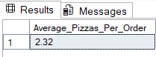

- DAILY TREND FOR TOTAL ORDERS
SELECT DATENAME(DW,order_date) AS Order_Date,
COUNT(DISTINCT order_id) AS Total_Orders
FROM pizza_sales GROUP BY DATENAME(DW,order_date);
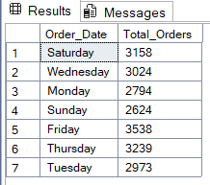

- HOURLY TREND FOR TOTAL ORDERS
SELECT DATEPART(HH,order_time) AS Order_Date,
COUNT(DISTINCT order_id) AS Total_Orders
FROM pizza_sales
GROUP BY DATEPART(HH,order_time)
ORDER BY DATEPART(HH,order_time);

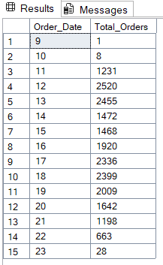

- % OF SALES BY PIZZA CATEGORY
SELECT pizza_category,
CAST(SUM(total_price) AS DECIMAL(10,2)) AS Total_Revenue,
(CAST(SUM(total_price)*100/
(SELECT SUM(total_price) FROM pizza_sales) AS DECIMAL(10,2))) AS PCT FROM pizza_sales
GROUP BY pizza_category;

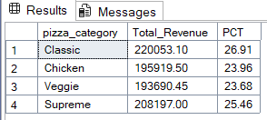

- % OF SALES BY PIZZA SIZE
SELECT pizza_size,
CAST(SUM(total_price) AS DECIMAL(10,2)) AS Total_Revenue,
(CAST(SUM(total_price)*100/
(SELECT SUM(total_price) FROM pizza_sales) AS DECIMAL(10,2))) AS PCT FROM pizza_sales
GROUP BY pizza_size
ORDER BY pizza_size;

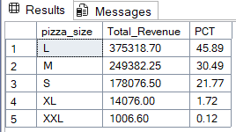

- TOTAL PIZZA SOLD BY PIZZA CATEGORY
SELECT pizza_category, SUM(quantity) AS Total_Pizzas_Sold
FROM pizza_sales
GROUP BY pizza_category
ORDER BY Total_Pizzas_Sold DESC;

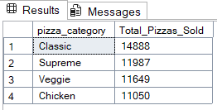

- TOP 5 BEST SELLERS BY TOTAL PIZZAS SOLD
SELECT TOP 5 pizza_name, sum(quantity) AS Total_Pizzas_Sold
FROM pizza_sales
GROUP BY pizza_name
ORDER BY Total_Pizzas_Sold DESC;

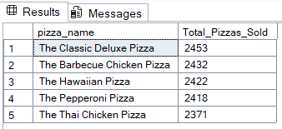

- BOTTOM 5 SELLERS BY TOTAL PIZZAS SOLD
SELECT TOP 5 pizza_name, sum(quantity) AS Total_Pizzas_Sold
FROM pizza_sales
GROUP BY pizza_name
ORDER BY Total_Pizzas_Sold ASC;

